**DAILY ONLINE ACTIVITIES SUMMARY**

|  |  |  |  |  |  |  |  |  |
| --- | --- | --- | --- | --- | --- | --- | --- | --- |
| **Date:** | **28-05-2020** | | | | | **Name:** | **Preethi** | |
| **Sem & Sec** | **6th - B** | | | | | **USN:** | **4AL17CS065** | |
| **Online Test Summary** | | | | | | | | |
| **Subject** | | **Operating System** | | | | | | |
| **Max. Marks** | | **30** | | **Score** | | | **26** | |
| **Certification Course Summary** | | | | | | | | |
| **Course** | **Introduction to Information Security** | | | | | | | |
| **Certificate Provider** | | | **greatlearning** | | **Duration** | | | **5.5 hours** |
| **Coding Challenges** | | | | | | | | |
| **Problem Statement: 1 java and 1 Python program** | | | | | | | | |
| **Status: executed** | | | | | | | | |
| **Uploaded the report in GitHub** | | | | | **Yes** | | | |
| **If yes Repository name** | | | | | <https://github.com/PreethiNayak/Daily-Status/tree/master/28May2020> | | | |
| **Uploaded the report in slack** | | | | | **Yes** | | | |

Online Test Details: (Attach the snapshot and briefly write the report for the same)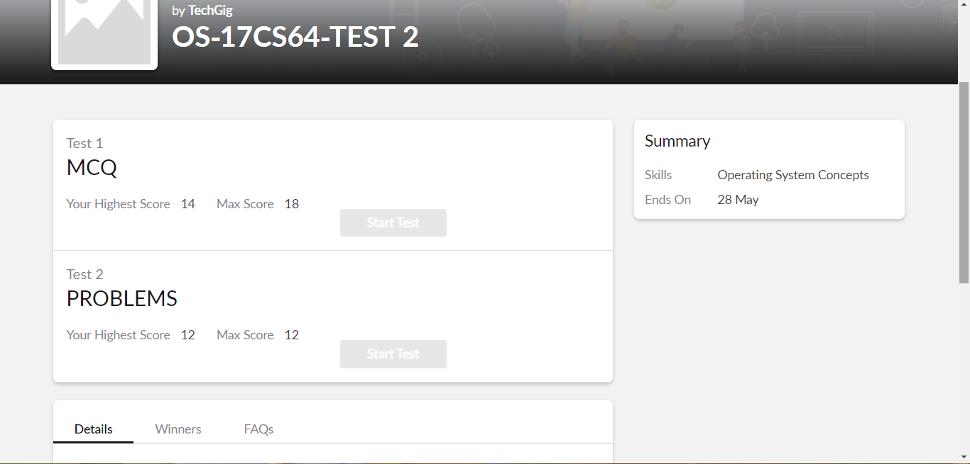

Certification Course Details: (Attach the snapshot and briefly write the report for the same)

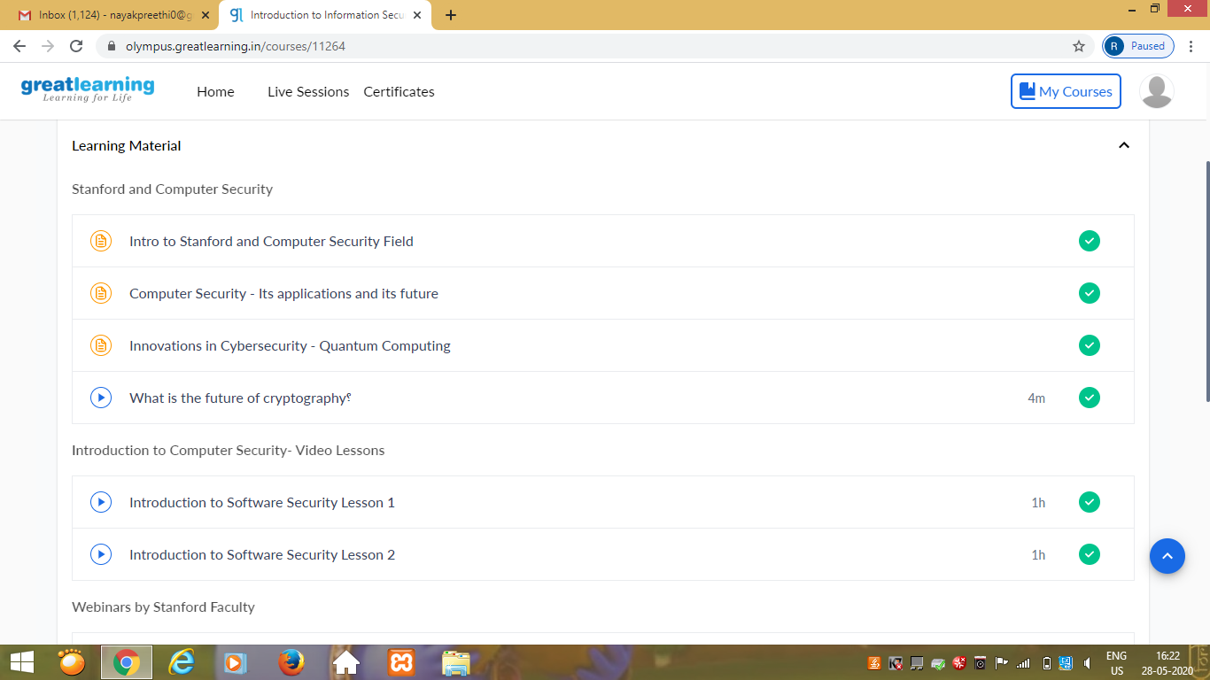

Today I learnt detailed information about “Introduction on Software Security Lesson 2”

In that I learnt,

1)Software Security goals and its implementation.

2)How Worms and Malware works?

3)3 objectives of information security.They are Confidentiality,Integrity and availability.

4)Princilpes that governs information security programs.

Coding Challenges Details: (Attach the snapshot and briefly write the report for the same)

OUTPUT SCREEN-SHOTS

Program 1

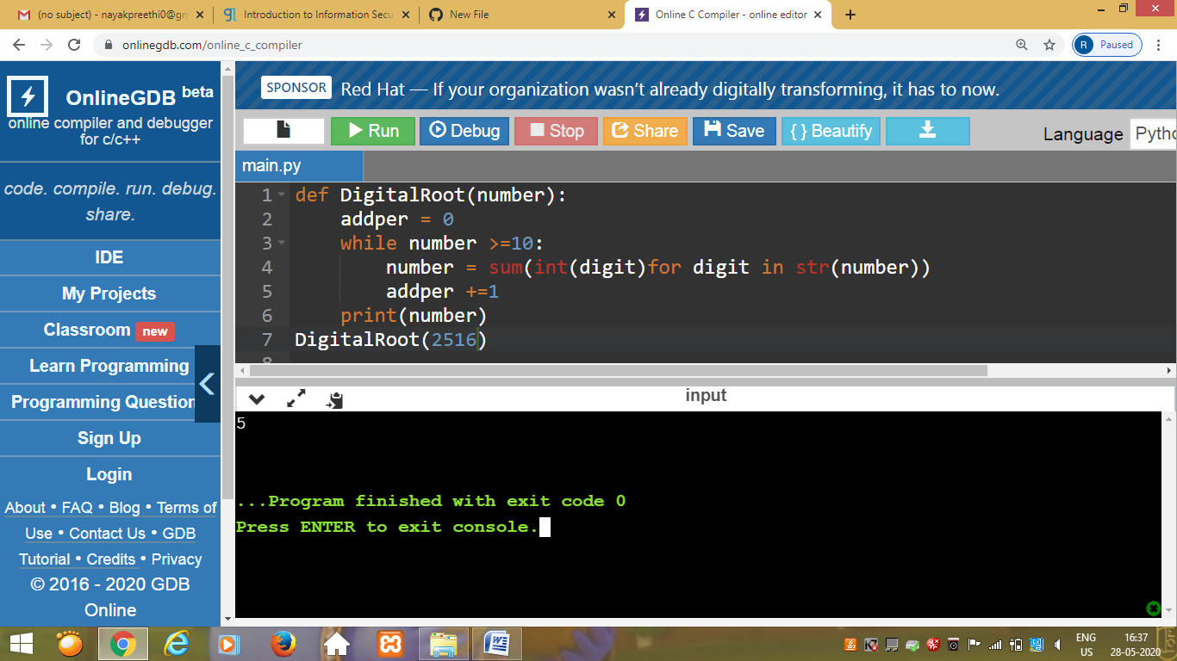

This is output of python program to find the digital root of the number.(Digital root is recursive sum of all the digits in a number.)

Program 2

This is the output of the java program to display “true” if given input in the program contains balanced brackets else it returns “false”.

